**STARCH**

**HERO**



Starch is a widely used carbohydrate essential to both food and industrial applications. Flexicon bulk material handling equipment is engineered to move, store, and process starch safely and efficiently across diverse environments.

**Button**: Talk To Us

**SHELF #1 - PRODUCT DESCRIPTION**

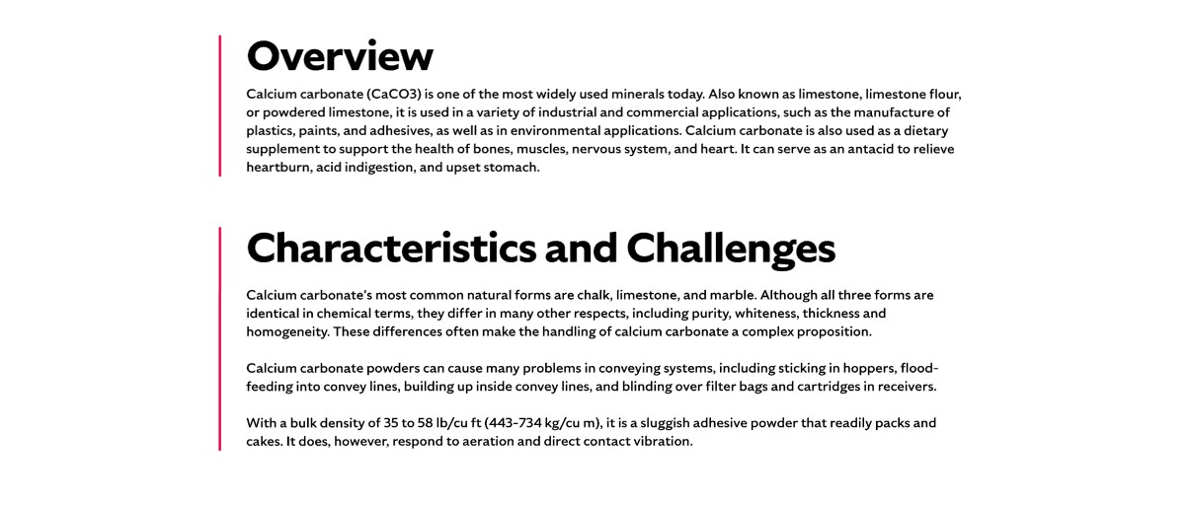

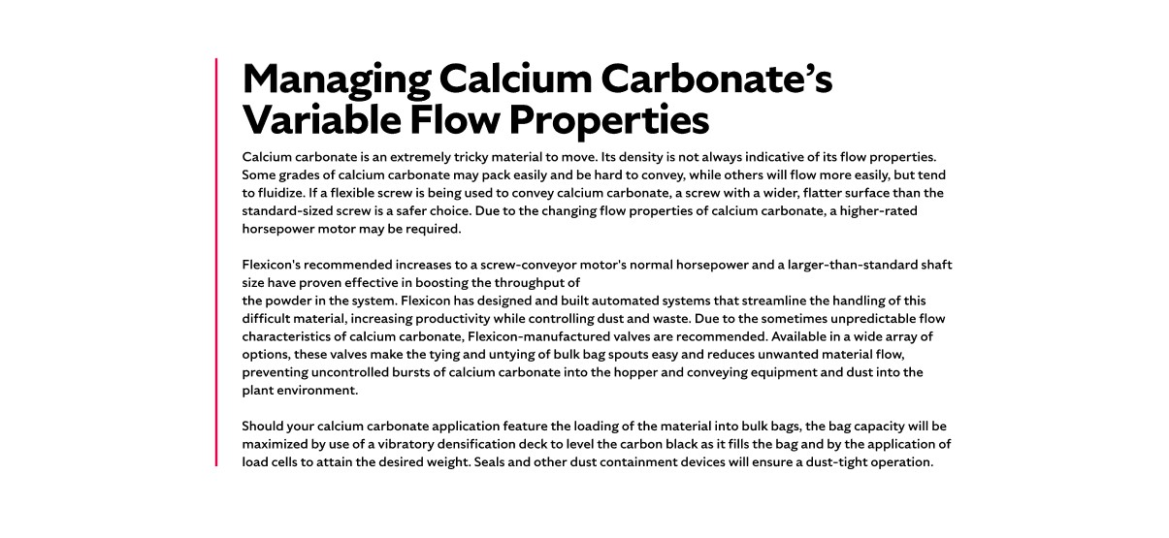

**Overview**Starch is a vital carbohydrate found in staple foods such as rice, wheat, maize, potatoes, and cassava. It plays a central role in food processing, serving as a thickening and stabilizing agent in products like soups, sauces, and desserts. Beyond its nutritional value, starch is the most common carbohydrate in the human diet and is consumed globally in massive quantities. Industrially, starch is indispensable. The largest non-food application is in papermaking, where it enhances paper strength and surface quality. In construction, starch is used in the production of gypsum wallboard. It’s also a key ingredient in a wide range of adhesives, including those used for bookbinding, wallpaper, paper sacks, tube winding, envelopes, school glues, and bottle labeling. These diverse applications make starch a foundational material across both food and non-food industries.

**Characteristics and Challenges**Starch is typically a dry, fine powder, but its flow characteristics vary depending on its plant source and moisture content. While dry starch may flow freely—even continuing to move after conveyors stop—moist starch tends to clump and resist movement. Long-term storage without agitation can reduce flowability, while repeated transfers may alter particle distribution, causing separation and spoilage. Starch also fluidizes easily, behaving like a liquid, which can complicate handling. Moisture exposure, especially during rail or silo storage, is a major concern and may require inline air dryers or properly sized blowers to maintain consistent flow during pneumatic conveying.

Improper starch handling can lead to costly downtime, product loss, and safety hazards. Starch dust is highly explosive, so all motors must be explosion-proof, and equipment must be grounded to prevent static buildup. Storage silos should include static relief valves to mitigate collapse risks from bridging. Starch also tends to bridge or "rat hole" in hoppers, requiring smooth hopper geometry and flow-aid devices like air fluidizers or agitators. When conveying starch on an incline, it's important to use a flexible screw designed for the material’s unique behavior—typically one with a broader, flatter profile to ensure smooth, consistent movement without clogging or backflow.

**SHELF #2 - FLEXICON SOLUTIONS**

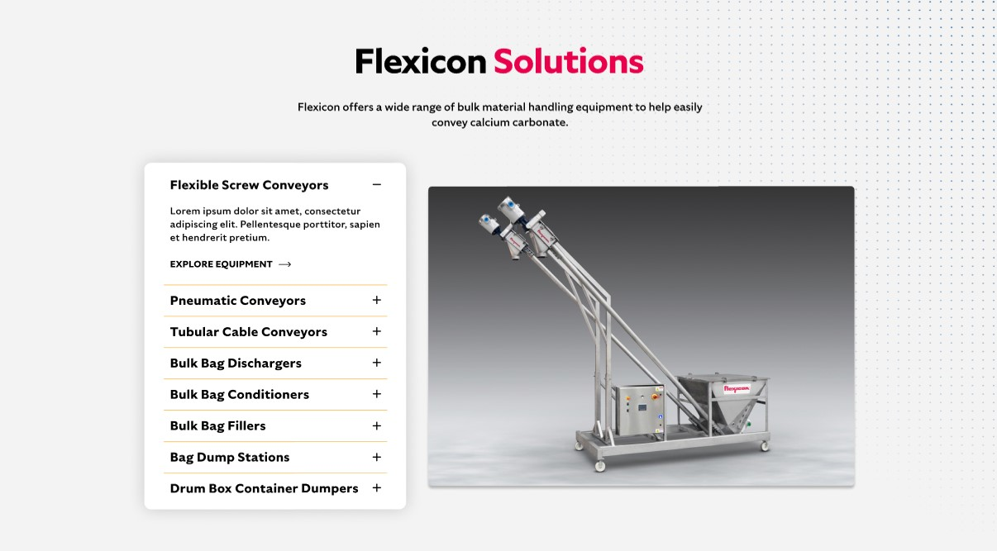

**Flexicon Solutions**

Flexicon offers a wide range of bulk material handling equipment to help easily convey starch.

**Flexible Screw Conveyors:** Reliably transport starch powders that tend to compact or behave like liquids, ensuring smooth flow.

**Pneumatic Conveyors:** Maintain clean, enclosed starch transfer with advanced filtration and automated dust recovery.

**Tubular Cable Conveyors:** Provide secure, space-saving starch movement through enclosed pathways ideal for sensitive environments.

**Bulk Bag Dischargers:** Enable controlled, dust-free emptying of starch from bulk bags into downstream systems.

**Bulk Bag Conditioners:** Restore flowability by breaking up hardened starch inside bulk bags before discharge.

**Bulk Bag Fillers:** Deliver precise starch filling into bulk bags with integrated dust control and weight accuracy.

**Bag Dump Stations:** Facilitate manual starch unloading with built-in dust collection and ergonomic design.

**Drum/Box/Container Dumpers:** Safely shift starch from smaller containers into processing lines while minimizing dust and manual effort.

**SHELF #3: LIFETIME PERFORMANCE GUARANTEE**

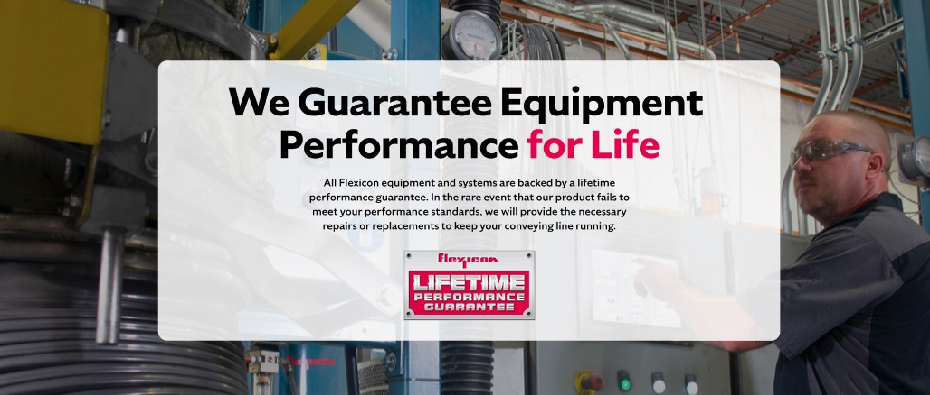

**Lifetime Performance Guarantee**

All Flexicon equipment and systems are backed by a lifetime performance guarantee. In the rare event that our product fails to meet your performance standards, we will provide the necessary repairs or replacements to keep your conveying line running.

**SHELF #4: CASE STUDIES**

